**THE PASSION MANIFESTO**

**STEP-BY-STEP ACTION GUIDE**

**PART 1. Adoption the right mindset**

**Uncovering your assumption**

What unchallenged assumption(s) could prevent you from designing your ideal career?

**Believing you can**

On a scale of 1 to 10, how committed are you to achieve your career goal?

|  |
| --- |
| 0 10 |

**Taking one hundred percent responsibility**

In what way are you not taking full responsibility for your career? Write down all the excuses or limiting beliefs that comes to mind.

**You’re the creator of your life**

On a scale of 1 to 10, how true are the following statements

I don’t expect people to give me a job

|  |
| --- |
| 0 10 |

I know myself well

|  |
| --- |
| 0 10 |

I always think of ways to add value

|  |
| --- |
| 0 10 |

I constantly learn new skills

|  |
| --- |
| 0 10 |

I ask myself the right questions

|  |
| --- |
| 0 10 |

I focus on what I want most of the time

|  |
| --- |
| 0 10 |

I don’t give up

|  |
| --- |
| 0 10 |

I leave no stone unturned

|  |
| --- |
| 0 10 |

**Facing the truth**

Answer the following questions with absolute honesty:

Do you love your current job?

Why I’m doing what I’m currently doing? Who sold me on that plan?

**PART 2. Finding out who you are**

**Knowing your personality**

*Your innate talent*

Write down your talents. To help you try answering the following questions:

* What come so easily to me that I can’t understand why other people struggle doing it?
* What doesn’t seem like work to me (though it is for other people)?
* What is my unique talent? What is it that only me can do?
* What activities can I find myself lost in for hours?
* What am I often complimented for?
* What am I doing/talking about when I feel the most energized?

Look at your list and try to identify activities you both love doing *and* excel at.

My talents:

Send an email to people who know you and ask them some of the following questions:

* What do you think my unique gift is?
* What are the three qualities you admire the most about me?
* What am I doing or talking about when I seem the most energized, happy and confident?
* What would you miss most about my presence if I passed on?

*Interpersonal relationships*

Tribal vs. Maestro

Are you a Tribal or a Maestro? Refer to the table below to help you answer that question.

|  |  |
| --- | --- |
| **Tribal vs. Maestro** | |
| **Tribal** | **Maestro** |
| You prefer to be part of team | You prefer to do things on your own |
| You enjoy team sports/activities | You prefer solo sports/activities |
| You tend to collaborate with others | You prefer your own ideas |
| You fit in naturally | You tend to be on your own wavelength and must make an effort to fit |
| You don’t go too deep in your interest areas | You like to go deep and become a master in a specific field |

Cooperation vs. competition

Take the free Big Five Personality test [here](https://www.truity.com/test/big-five-personality-test-b). If you score high for agreeableness you’re likely more driven by cooperation. If your score is rather low you’re probably more of a competitor. Now, does your current job allow you to express that aspect of your personality? If not why?

*Your energy type*

Tak the following test to assess whether you’re an introvert or an extrovert.

<https://www.quietrev.com/the-introvert-test/>

If you’re an introvert, you can check my book *The Thriving Introvert: Embrace the Gift of Introversion and Live the Life You Were Meant to Live*.

**Knowing your core values**

*Identify your top 10 core values*

Write down your top 10 values, that is, the things that matter the most to you. Remember that they areyour values. Don’t try to look good by selecting noble values that you know aren’t your values. Be honest with yourself.

|  |  |
| --- | --- |
| **My top 10 core values** | |
| Core value #1 |  |
| Core value #2 |  |
| Core value #3 |  |
| Core value #4 |  |
| Core value #5 |  |
| Core value #6 |  |
| Core value #7 |  |
| Core value #8 |  |
| Core value #9 |  |
| Core value #10 |  |

*Prioritize your core values (put a number next to each core value)*

Ask yourself, if I could only keep one core value what would that be? Repeat the process for each value.

**PART 3. Finding Out What You Want**

**Find out what you really want**

Write down what you want.

Imagine that you could have absolutely anything you want, what would that be. Spend five to ten minutes to write down everything you want. (Feel free to use a separate piece of paper if needed)

-

-

-

-

-

-

-

-

-

-

-

-

-

-

-

-

-

Select ten things you really really want then, write down the emotional value(s) behind each thing. To do so you can use Tony Robbins’ six human needs:

1. Certainty: The need for security
2. Uncertainty: The need for variety in your life
3. Significance: The need to feel like you matter
4. Connection/love: The need to connect with people and feel loved
5. Growth: The need for personal growth
6. Contribution: The need to make a difference

Alternatively, you can write down whatever values seem relevant to these things you want (freedom, family, uniqueness etc.)

|  |  |  |  |
| --- | --- | --- | --- |
| **Clarifying what you want** | | | |
| # | **What I want** | **Why?** | **What it says about me** |
| 1 |  |  |  |
| 2 |  |  |  |
| 3 |  |  |  |
| 4 |  |  |  |
| 5 |  |  |  |
| 6 |  |  |  |
| 7 |  |  |  |
| 8 |  |  |  |
| 9 |  |  |  |
| 10 |  |  |  |

Write down your dream career

Now, write down what your career would look like if you could have anything you want. Don’t limit yourself. How many hours would you work? What would you be doing in the morning? In the afternoon? How much money would you earn? Be as specific as you possibly can. Remember, clarity is power.

|  |  |
| --- | --- |
| **My dream career** | |
| **What I want** | **Why it’s important to me** |
|  |  |
|  |  |
|  |  |
|  |  |
|  |  |
|  |  |
|  |  |
|  |  |
|  |  |
|  |  |

**Finding out what you love**

**20 Things you Love to Do** (Write down at least 20 things that you love to do in your everyday life)

|  |  |  |  |
| --- | --- | --- | --- |
|  | **What I love to do the most** | **Why?** | **What it says about me** |
| 1 |  |  |  |
| 2 |  |  |  |
| 3 |  |  |  |
| 4 |  |  |  |
| 5 |  |  |  |
| 6 |  |  |  |
| 7 |  |  |  |
| 8 |  |  |  |
| 9 |  |  |  |
| 10 |  |  |  |
| 11 |  |  |  |
| 12 |  |  |  |
| 13 |  |  |  |
| 14 |  |  |  |
| 15 |  |  |  |
| 16 |  |  |  |
| 17 |  |  |  |
| 18 |  |  |  |
| 19 |  |  |  |
| 20 |  |  |  |

**Identifying the top 5 things you love the most**

Out of the 20 things you love the most, select the top five things you really love.

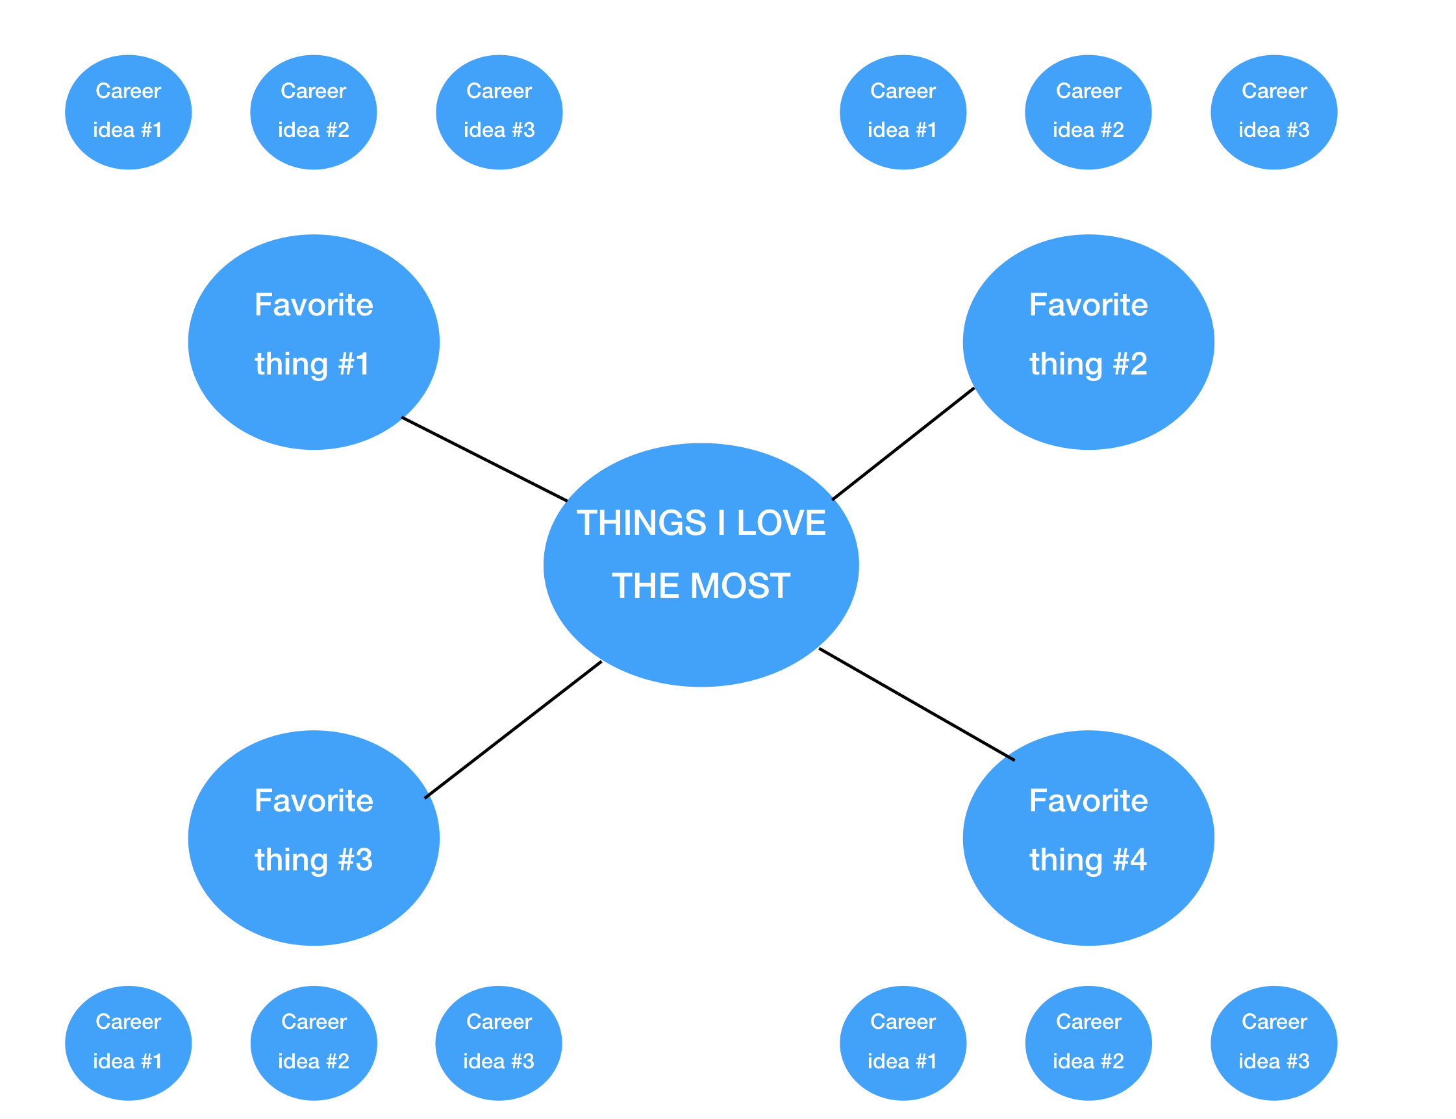

|  |  |  |  |
| --- | --- | --- | --- |
|  | **My top 5 things** | **Why?** | **What it says about me** |
| 1 |  |  |  |
| 2 |  |  |  |
| 3 |  |  |  |
| 4 |  |  |  |
| 5 |  |  |  |

For each thing you love, write down all the ways you could potentially make money out of it. Dig deeper and look for potential jobs or careers that could be a good fit for you. (see template on the right)

Use the template below or a separate piece of paper to brainstorm career ideas. (A3 paper recommended).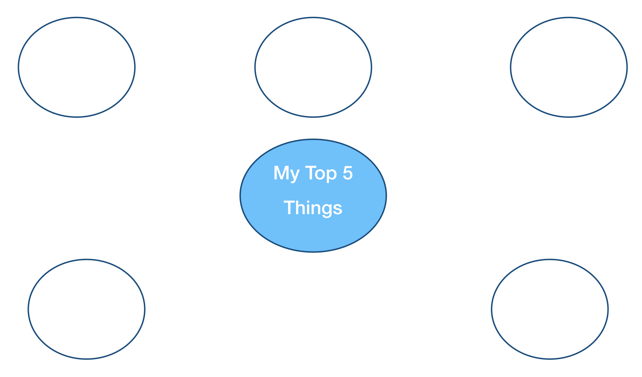

Let’s gather further clues by looking at your passions and interests. Fill in the table below.

|  |  |  |  |
| --- | --- | --- | --- |
| **Passion/interests** | | | |
| **What I focus my attention on** | **What I do willingly** | **What I can learn from past experiences** | **What my dreams are** |
| * What do I daydream about? * When I get bored, what do I think about? * Do I often get lost in your thoughts? If so, what thoughts am I having? * What do I think about before going to sleep or when I wake up? * What do I think about when I take a shower? Drive? Commute to work? | * What are you naturally drawn to do during your spare time? * What do/did you volunteer for at work or outside of work? | * What did you enjoy doing when you were a kid? * What past successes are you most proud of? | * What would you do if you had all the time and money in the world? * What would you do if you could not fail? * What do you want to be remembered for? * Imagine you just passed away. Your family and friends are attending your funeral. What are they saying? What do you want them to say about you? * What do you want your (future) kids to do with their lives? |
|  |  |  |  |

Now, let’s see what we can learn from your feelings.

|  |  |  |  |
| --- | --- | --- | --- |
| **What my feelings tell me** | | | |
| **Jealousy** | **Curiosity** | **Pain (issues/challenges)** | **Excitement** |
| Who do you envy, admire or feel jealous of? | What are you curious about and would like to learn more of? | What painful issues or challenges have you faced in your life? | When was the last time you feel excited in a conversation? What was the topic(s)? |
|  |  |  |  |
| **Anger** | **Hate** | **Intuition** | **Comments (if any)** |
| What makes you angry? What do you find outrageous? | What do you hate doing? | Listen to your inner voice. What does it tell you to do? What do you honestly believe you’re supposed to do with your life? |
|  |  |  |  |

In this table, you’ll write down any clues that can help you identify your ideal career.

|  |  |  |  |
| --- | --- | --- | --- |
| **Clues for my future career** | | | |
| **Hints**  Any idea you deem relevant. (Ex: X, Y or Z could be fun) | **What is a MUST**  (Ex: Working from home etc.) | **What is a BIG NO!**  (Ex: Working in a specific industry, having a boss etc.) | **Career ideas**  (any career ideas you want to explore) |
|  |  |  |  |
|  |  |  |  |
|  |  |  |  |
|  |  |  |  |
|  |  |  |  |
|  |  |  |  |
|  |  |  |  |
|  |  |  |  |
|  |  |  |  |
|  |  |  |  |
|  |  |  |  |
|  |  |  |  |
|  |  |  |  |
|  |  |  |  |
|  |  |  |  |
|  |  |  |  |

|  |  |  |  |
| --- | --- | --- | --- |
| **Clues for my future career** | | | |
| **Hints**  (Any idea you deem relevant. Ex: X, Y or Z could actually be fun) | **What is a MUST**  (ex: Working from home etc.) | **What is a BIG NO!**  (ex: Working in IT) | **Career ideas**  (any career ideas you want to explore) |
|  |  |  |  |
|  |  |  |  |
|  |  |  |  |
|  |  |  |  |
|  |  |  |  |
|  |  |  |  |
|  |  |  |  |
|  |  |  |  |
|  |  |  |  |
|  |  |  |  |
|  |  |  |  |
|  |  |  |  |
|  |  |  |  |
|  |  |  |  |
|  |  |  |  |
|  |  |  |  |
|  |  |  |  |

**Creating a mission statement**

Before you create your own mission statement, let’s review the differences between a job and a mission

|  |  |
| --- | --- |
| **Job vs. Mission** | |
| **Job** | **Mission** |
| Encompass your **professional life only** | Encompass both your **personal *and* professional life** |
| **Rigid** (when you lose your job you lose your purpose) | **Flexible** (Can be fulfilled in may different ways) |
| **Temporary** (can be turn off and on) | **Constant** (You embody it) |
| May or may not be aligned with your values | aligned with your values |

**How to create your mission statement**

Now let’s use the three steps below to help you create your mission statement.

Step 1: Find out what your means of expression is.

Ask yourself how you want to express yourself and how you want people to feel as a result of it

Examples*: Teaching, inspiring, entertaining, organizing, building, inventing, touching people’s heart with your art, supporting etc.*

Step 2: Clarify what you stand for

What cause, principle, value or purpose do you want to defend the most? Ask yourself, “if I could embody one thing, what would that be?”

Examples*: Creativity, excellence, freedom, joy, faith, justice, passion, compassion, truth etc.*

Step 3: Identify who you are here to serve

What group of people, organizations or causes do you want to support?

Examples:

* Groups: *Children, the elderly, homeless people, drug addicts, researchers, entrepreneurs, stay-at-home mums etc.*
* Organizations: *Government, NPOs, small businesses, businesses in a specific industry or country etc.*
* Causes/issues: *Women issues, cancer, animals rights, hunger, domestic violence etc.*

Your turn now.

|  |  |  |
| --- | --- | --- |
| **Your mission statement** | | |
| **Step 1** | **Step 2** | **Step 3** |
| My means of expression | What I stand for | Who I want to serve |
|  |  |  |

My mission is:

Now, read your statement. Does it inspire you? If so, well done. If not, spend some more time working on it. You can also leave it as is for now and work on it later on as you clarify your purpose.

**Creating a long-term vision**

To create your long-term vision will look at your personality, values and mission. In addition, we’ll also work on creating your ideal day and envisioning the person you want to become.

|  |  |  |
| --- | --- | --- |
| **My Ideal Day** | | |
| Morning | What will you do first thing in the morning?  What will you be eating for breakfast?  What will you be doing? |  |
| Lunch | What will you eat for lunch?  Will you eat out or at home?  Who will you eat with?  How long will your lunch break be? |  |
| Afternoon | What will you be doing? Will you be working?  How long will you be working?  What fun activities will you be doing? |  |
| Evening | What will you be doing  Who will you spend your time with?  What will you eat for dinner  Will you eat out or at home? |  |

|  |  |
| --- | --- |
| **Who I want to become** | |
| Skills I want to develop | Qualities I want to embody |
|  |  |
|  |  |
|  |  |
|  |  |
|  |  |
|  |  |
|  |  |
|  |  |
|  |  |
|  |  |
|  |  |
|  |  |

Now, let’s look at all the reasons why your vision is important to you. How is it aligned with your values, personality and mission? What are other reasons your vision matters?

|  |  |
| --- | --- |
| **Why my vision is important** | |
| **How it is aligned with my values** |  |
|  |
|  |
|  |
|  |
| **How it is aligned with my personality** |  |
|  |
|  |
|  |
| **How it is aligned with my mission** |  |
|  |
|  |
|  |
|  |
| **Other reasons** |  |
|  |

**PART 4. Winning the inner game**

The table below gives you an overview of the key mindset to develop to achieve your career goal.

|  |  |  |  |  |
| --- | --- | --- | --- | --- |
|  | **Asking Mindset** | **I Can Mindset** | **I Will Mindset** | **Designing An Empowering Environment** |
| **Description** | Giving yourself permission to pursue your goal and accepting you’re worthy of it. | Removing mental blocks and believing you can achieve your goals. | Developing a long-term perspective and sticking to your goal until you achieve it. | Surrounding yourself with a team of people who fully support you. |
| **Results** | With an *Asking Mindset* you broadcast your desire to the world and ask for what you want. | With an *I Can Mindset* you take action towards your goal with little to no inner resistance | With a *I Will Mindset* you move towards your goals with consistency and great patience until you get the results you want. | You surround yourself with role models, mentors and supporters who will help you achieve your goals |
| **Characteristics** | Broadcast your desire | Overcome fears | Understand the time and effort needed | Surround yourself with positive people |
| Ask for what you want | Overcome self-doubt | Persevere | Expose yourself to inspirational content |
| Give unconditionally | Clarify what you want | Focusing on the journey | Set powerful daily habits |
| Ask for more you think you can get | Overcome your limiting beliefs |  |  |

**Developing an *Asking Mindset***

Broadcasting your desire

On a scale of 1 to 10 how much would you say you currently share your desires?

|  |
| --- |
| 0 10 |

What is one thing that if you dare asking would make the biggest difference in your career right now?

Why haven’t you already asked?

Rate yourself on a scale of 1 to 10 for the following:

Fear of rejection

|  |
| --- |
| 0 10 |

Fear of disturbing

|  |
| --- |
| 0 10 |

Fear of not being good enough

|  |
| --- |
| 0 10 |

Pride

|  |
| --- |
| 0 10 |

What one thing could you challenged yourself to ask for this week?

**Developing an *I Can Mindset***

**Removing mental blocks and limiting beliefs**

Write down all the reasons why you haven’t achieved your goal (or may not be able to achieve it):

-

-

-

-

-

-

-

Look at each thing you wrote down and ask yourself :

1. Is that really true? Is there absolutely nothing I can do about it?

2. If I were 100% committed what would I do? What would it look like?

Look for counter-examples. Select the biggest reason why you haven’t achieve or can’t achieve your career goal. Look for people in the same situation as you (or worse) who have achieved a similar goal. You can jot down any case studies you find at the end of this action guide or in a dedicated journal.

**Writing down your new belief**

Now that you have identified what limiting beliefs are holding you back, it’s time that you write down your new belief. Ask yourself, What new empowering belief(s) could I implement instead of that old belief?

Let’s look at some concrete examples:

* I don’t have time —> I make the time for what is important to me
* I’m too old —> Age is just a number. Other people have achieved similar goal and so will I!
* There is too much competition —> I’m fully committed to achieve my goal. Competition is irrelevant Or

—> I believe in cooperation. The more I cooperate, the more successful I become.

**Turning your belief into affirmations**

Use your new belief as an affirmation you repeat every day.

**Developing an *I Will Mindset***

*Rate yourself on a scale of 1 to 10 for the following (1 being false):*

When I set goals I tend to misjudge the amount of time and effort needed

|  |
| --- |
| 0 10 |

What I could do about it:

I tend to give up prematurely when I don’t obtain the results I want

|  |
| --- |
| 0 10 |

What I could do about it:

I overly focus rather than enjoying the journey

|  |
| --- |
| 0 10 |

What I could do about it:

**Designing an empowering environment**

1. Surrounding yourself with positive people who will uplift you

2. Exposing yourself to inspirational content

3. Setting powerful habits that will improve your mood long-term

**1. Surrounding yourself with positive people**

On scale of 1 to 10 how empowering your environment is?

|  |
| --- |
| 0 10 |

What are some of the things that if you were to do would drastically improve your environment and increase the chances you achieve your goals?

-

-

-

-

-

**2. Exposing yourself to inspirational content**

What could you do to expose yourself to inspirational content on a daily basis?

What are 2 to 3 role models that you could learn from (either in person or online)?

**3. Forming powerful long-term habits**

What are two or three habits that if you were to perform every day would help you achieve your goals in the long-term?

-

-

-

**PART 5. Setting the ideal goal**

**1. Finding the essence of your goal**

Write down below the essence of your goal to the best of your ability. To further identify the essence of your goal answer the following questions:

• Could your goal—or a similar goal— be viable in a totally different industry? If so, how would you feel about it?

• What are the core values behind your goal? Could other goals allow you to express these core values in a similar way?

• How do you express yourself through this goal? Do you entertain people? Educate them? Heal them? Build something or invent something new?

• Could you come up with different goals that would allow you to express yourself in similar ways? (For instance, giving private courses to students or teaching English to employees instead of teaching English in High-school)

• If you could achieve only part of your goal, what would be the minimum you’d be satisfied with? Why? Think in term of:

⁃ **Money:** What if your salary was only half of what you want?

⁃ **Location:** What if you have to live in the countryside rather than in a big city or vice-versa? In a different part of the world? In a smaller house/apartment?

**⁃ Work environment**: What if you could do the same job but had to sit in front of a desk rather than at home/self-employed? What if you had to work in team rather than alone?

⁃ **Time spent on your goal:** What if you could only work on your goal part-time(For instance, a writer who could write only twenty percent of his time)

**⁃ Working hours:** What if you had to work longer hours? Would you accept that job? And how many hours per week would you be willing to work?

**⁃ Schedule:** Would you be willing to work late at night or weekends?

**2. Identifying the emotional core behind your goal**

|  |  |  |
| --- | --- | --- |
| **Your goal:** | | |
|  | **Emotional core** | **Value(s)** |
| Example: create an online business | Spend more time with your wife and your kids | family |
| **#1** |  |  |
| **#2** |  |  |
| **#3** |  |  |
| **#4** |  |  |
| **#5** |  |  |

**3. Energizing your goal**

|  |  |  |
| --- | --- | --- |
| **Your goal:** | | |
|  | **What that would look like** | **Why it matters** |
| Example: create an online business | • I would enjoy a slow breakfast with my spouse and kids each morning.  • I would go to every single soccer game of my son  • I would spend quality time with my wife each night | I want to be here for my family. I don’t want to miss key moments with my children because of my work. |
| **#1** |  |  |
| **#2** |  |  |
| **#3** |  |  |
| **#4** |  |  |
| **#5** |  |  |

**Mind map example**

Alternatively, you can create a mind map following the example below. Feel free to use the blank page below or a separate piece of paper to create your mindmap.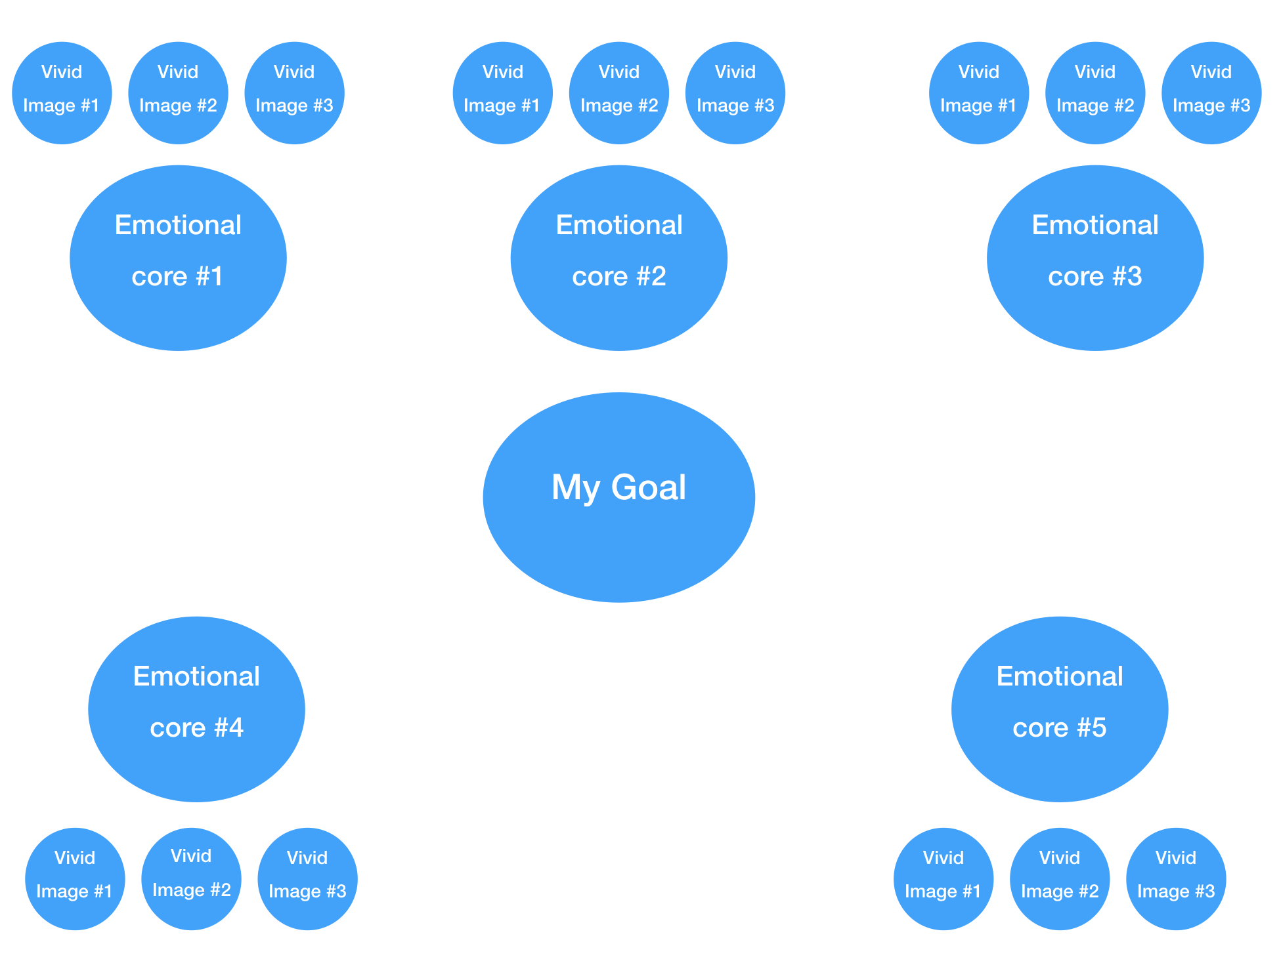

**4. Integrating your goal in your life**

**The Five Lives exercise**

Imagine you were granted five lives. How would you live each one of them?

|  |  |  |
| --- | --- | --- |
| **Your Five Lives** | | |
|  | **What exactly would that look like?** | **Why does that matter?** |
| **Life #1** |  |  |
| **Life #2** |  |  |
| **Life #3** |  |  |
| **Life #4** |  |  |
| **Life #5** |  |  |

Now that you have your five lives, complete the following table.

|  |  |
| --- | --- |
| **Your Five Lives** | |
| What are your most important lives right now? |  |
| What lives could you combine? |  |
| What lives could you live simultaneously? |  |
| What lives could you alternate? |  |
| What lives could you live one after the other? |  |

**Shifting your identity**

Fill in the table below and write down who you would be if you had already achieved your goal.

After “My New Identity as” write down your new job/career. (ex: consultant, coach, entrepreneur, ranch owner, restaurant owner etc.)

|  |  |
| --- | --- |
| **My New Identity as** | |
| What would be my core beliefs about myself and about the world? |  |
| How would I think differently? |  |
| How would I feel? |  |
| What would I do differently? |  |
| What new habits would I have? |  |
| What old habits would I have gotten rid of? |  |

Write down your career goal in the middle and for each section (Core beliefs, feelings, actions/behaviors) write down the side effects (how you would think, feel and act if you had already achieved your goal)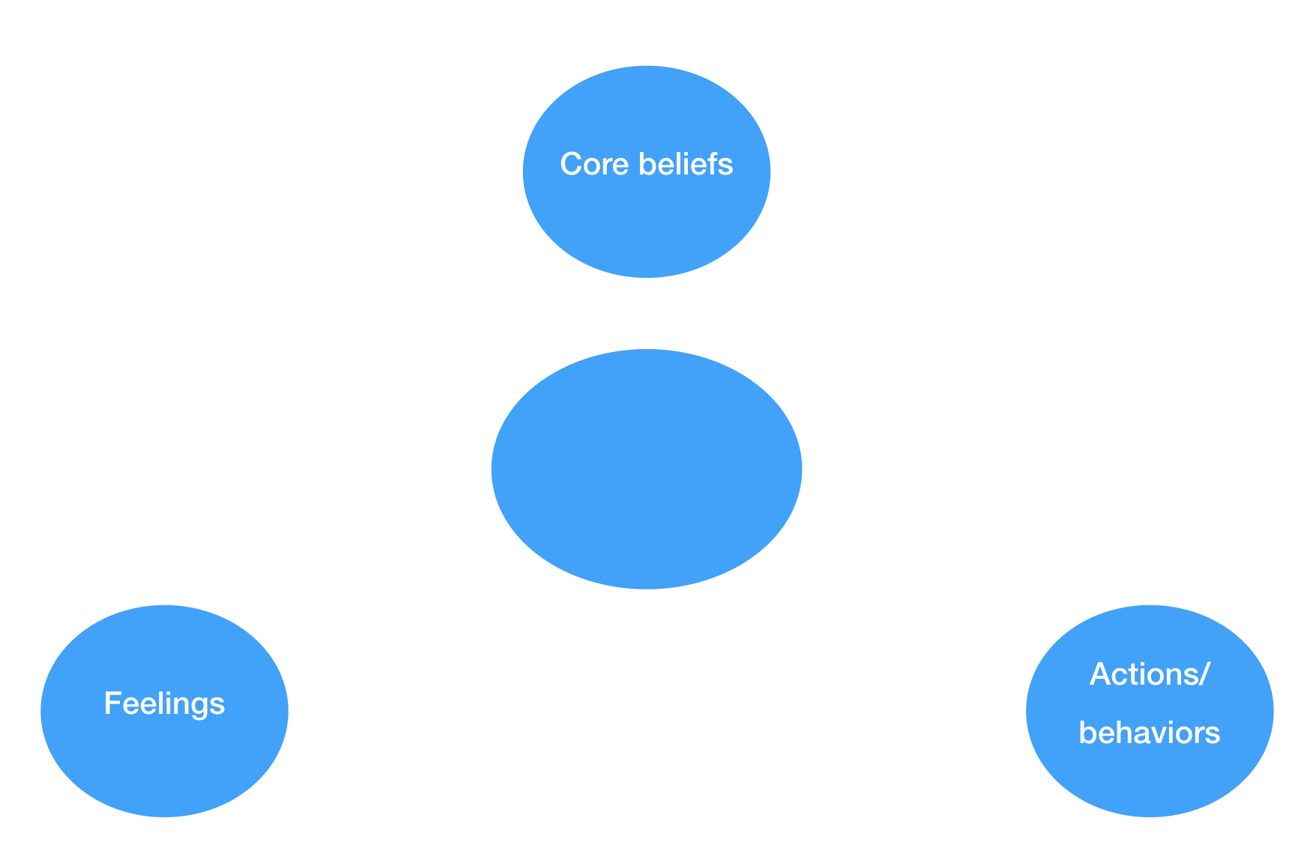

**Creating your goal statement**

Imagine you have achieved your goals and now live the perfect life being successful at what you love doing the most. How would you introduce yourself to someone asking you what you do for a living?

My goal statement:

**Part 6. Identifying the resources you need**

Write down all the resources you need to achieve your goal

• People: this can be people who can help you or people who can help find these people.

• Information: anything you need to know to maximize your chances of reaching your goal.

• Finance/materials: money or materials you need to achieve your goal.

• Time: additional time or ways to save time so that you can focus on designing your career as fast as possible.

|  |  |  |  |
| --- | --- | --- | --- |
| **Resources I need** | | | |
| **People** | **Information** | **Finance/materials** | **Time** |
|  |  |  |  |

**Finding the right people**

**Your personal network**

Make a list of all the people who could potentially help you. This includes:

• People who helped you in the past.

• People you helped in the past (and who may feel ‘obligated’ to help you)

• People with potential connections in the field you want to work in

• People with a certain influence and/or a big network

• People who could finance you or who know people who may

|  |
| --- |
| **People who could help me** |
|  |

|  |  |
| --- | --- |
| **How I can find the money** | |
| How much of the reason you’re not pursuing your goal is due to fear? |  |
| Is it really true you can’t finance your dream? If you were 100% committed what would you do? |  |
| Do you need a degree? |  |
| How much money do you really need? |  |
| Could you start for free? If so, how? |  |
| Do you need to reevaluate the essence of your goal? If so, How? |  |
| Do you need financial support? If so, what kind? |  |
| Can you make/save more money? If so, what could you do? |  |

**Finding information**

Make a list of books, blogs, videos, online courses and Facebook groups/forums that if you were to join would give you the best information possible.

|  |  |
| --- | --- |
| **Where I can find the information** | |
| Most helpful books |  |
| Most helpful videos |  |
| Most helpful blogs |  |
| Most helpful online courses |  |
| Most helpful Facebooks groups/forums |  |
| Other |  |

**Adopting a Mastery Mindset**

On a scale of 1 to 10, how true are the following statements

I’m victim of the Shiny Object Syndrome

|  |
| --- |
| 0 10 |

I lack patience

|  |
| --- |
| 0 10 |

I’m victim of the*“I Already Know That”* Syndrome

|  |
| --- |
| 0 10 |

My pride prevents me from learning what I should learn

|  |
| --- |
| 0 10 |

I’m complacent and stopped learning

|  |
| --- |
| 0 10 |

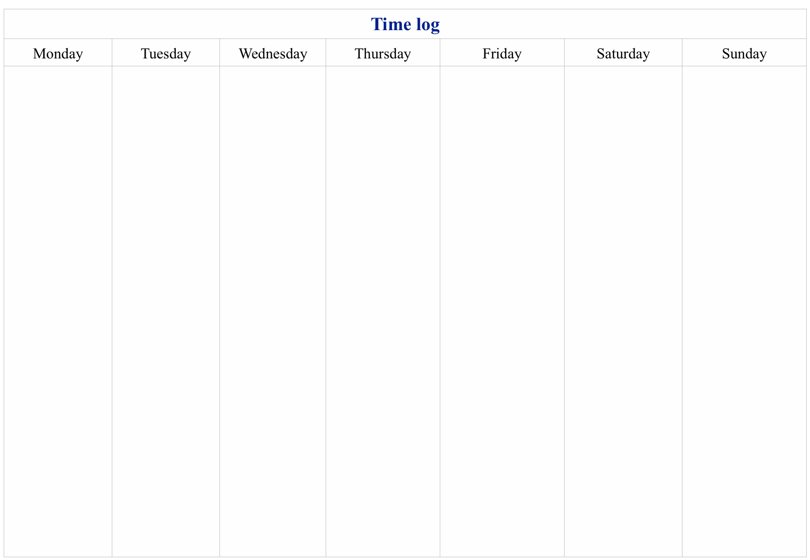**Finding the time**

**Creating a time log**

Commit to recording everything you do for an entire week. Write down each activity you engage in and how much time you spend on it. Do that in real time to make sure you don’t forget anything. You should include everything you do. It includes:

• What you do at work

• Breakfast/lunch/dinner

• TV/leisure time

**•** Commuting

**•** Etc.

**PART 7. Making it happen**

**Creating an action plan for your goal**

**1. Creating a list of tasks**

Use the space below or a separate sheet of paper and write down all the tasks you need to accomplish to achieve your career goals.

Focus on the key milestones first.

**2. Strategizing**

|  |  |
| --- | --- |
| **How I will strategize my actions** | |
| What are the **core skills** I must absolutely master to achieve that goal? |  |
| What are the **Key Success Factors** for that goal? What will determine whether I will achieve it or not? |  |
| What are the **worse case scenarios** I could encounter? How do I plan to deal with them? |  |
| How can I achieve that goal **faster**? (80/20 rule) |  |
| What could I do **every day** to increase the likelihood I achieve my goal? |  |

**3. Creating powerful daily habits**

Write down your daily habits. They should answer the following question:

if I keep doing what I’m doing today, will I be where I want to be ten years from now?

|  |  |
| --- | --- |
| **My powerful daily habits** | |
| **Powerful habit #1** |  |
| **Powerful habit #2** |  |
| **Powerful habit #3** |  |
|  |  |
|  |  |

**4. Scheduling**

Use the table below to insert your key milestones to the corresponding month.

Remember your plan doesn’t have to be perfect.

**Setting goals**

Write down 3 - 6 tasks you want to complete by the end of this year. (If you plan to achieve your career goal by the end of the year just write down that goal).

|  |  |
| --- | --- |
| **Yearly goals** | |
| **Taks #1** |  |
| **Taks #2** |  |
| **Taks #3** |  |
| **Taks #4** |  |
| **Taks #5** |  |
| **Taks #6** |  |

|  |  |
| --- | --- |
| **Quarterly goals** | |
| **Taks #1** |  |
| **Taks #2** |  |
| **Taks #3** |  |
| **Taks #4** |  |
| **Taks #5** |  |
| **Taks #6** |  |

Write down 3 - 6 tasks you want to complete this quarter (refer to the milestone in your schedule)

Write down 3 - 6 tasks you want to complete this month (refer to the milestone in your schedule)

|  |  |
| --- | --- |
| **Monthly goals** | |
| **Taks #1** |  |
| **Taks #2** |  |
| **Taks #3** |  |
| **Taks #4** |  |
| **Taks #5** |  |
| **Taks #6** |  |

Write down 3 - 6 tasks you want to complete this week (break down this month’s milestone in your schedule)

|  |  |
| --- | --- |
| **Weekly goals** | |
| **Taks #1** |  |
| **Taks #2** |  |
| **Taks #3** |  |
| **Taks #4** |  |
| **Taks #5** |  |
| **Taks #6** |  |

**Building accountability**

**How to create an accountability system that actually works**

To make the accountability partnership effective think of it as a contract between two people. And, as any contract:

1. **It has to be agreed to**. You both have to agree with the terms of the contract. What is means is that you believe the terms are reasonable and are confidence you can follow through.

2. **You have to commit to it**. You must be willing to commit to respecting the conditions in the contract and to pay the consequences when you don’t. Remember that your accountability partner is not your friends (at least not during your accountability meeting)

**3. It has to be specific**. It should lay out exactly what you will do, when and how. For an accountability system to be effective it must included the following points:

⁃ How you will communicate (email, phone, Skype, in person etc.)

⁃ How often (once a day/week/month)

⁃ How long you’ll work together (it’s a good idea to stay together until the deadline of one of a key milestone. Ideally, three months or more)

⁃ What exactly you’ll do during each session

⁃ What the consequences will be if you don’t follow through

⁃ How you will reward yourself when you follow through

**Questions to ask during the meeting:**

The partnership will be more effective if you know what questions to ask your partner. Below are some powerful questions I recommend you use during the meeting:

Reviewing past week goals:

• What went well this week?

• What could you have done better?

• What did you learn? What will you do better next time?

• What would you like to celebrate/acknowledge yourself for?

Brainstorming:

• What’s holding you back?

• What are your options here?

• Can you think of anything else?

Discussing next week goals:

• On a scale of 1 to 10, how confident are you that you will achieve that goals?

• What’s holding you back? What could you do about it?

• On a scale of 1 to 10, how committed are you to achieve that goal next week?

• Can you commit to that goal? Can you commit to achieve that goal on *add specific day*?

**THANK YOU SO MUCH!**

I hope you enjoyed this book and that you started taking action toward building your dream career.

Let me wish you all the best with your new endeavors. I’m very much looking forward to hearing from you on my website.

If you have any questions send me an email at [thibaut.meurisse@gmail.com](mailto:thibaut.meurisse@gmail.com)

* Click [here](https://www.facebook.com/whatispersonaldevelopment.org/) to connect with me on my Facebook page.
* Click [here](https://www.youtube.com/channel/UCyxE5waVyUmJguJQbHSqCyg?view_as=subscriber) to follow me on YouTube.
* Click [here](http://www.apple.com) to check out my author page.

Thanks a lot!

Thibaut Meurisse

Founder of [Whatispersonadevelopment.org](http://whatispersonaldevelopment.org/)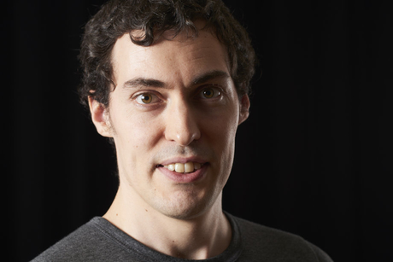

**Other books by the author:**

[Goal Setting: The Ultimate Guide to Achieving Goals That Truly Excite You](http://www.apple.com)

[Habits That Stick: The Ultimate Guide to Building Powerful Habits That Stick Once And For All](https://www.amazon.com/Habits-That-Stick-Ultimate-Building-ebook/dp/B01N2STH6F)

[Productivity Beast: An Unconventional Guide to Getting Things Done](https://www.amazon.com/Productivity-Beast-Unconventional-Getting-WORKBOOK-ebook/dp/B01NB9JBR6)

[The One Goal: Master the Art of Goal Setting, Win Your Inner Battles, and Achieve Exceptional Results](http://a.co/67KOntn)

[The Thriving Introvert: Embrace the Gift of Introversion and Live the Life You Were Meant to Live](http://a.co/5fXn9qT)

[Upgrade Yourself: Simple Strategies to Transform Your Mindset, Improve Your Habits and Change Your Life](http://a.co/9vdmP01)

[Wake Up Call: How to Take Control of Your Morning and Transform Your Life](https://www.amazon.com/Wake-Up-Call-Control-Transform-ebook/dp/B074P5X5PD)

**Did you enjoy this book?**

If you benefit from this book, make sure to leave a review on Amazon. You could inspire other people like you to make changes in their lives as well. And that would mean so much to me!



Thank you for your support!!

Thibaut

