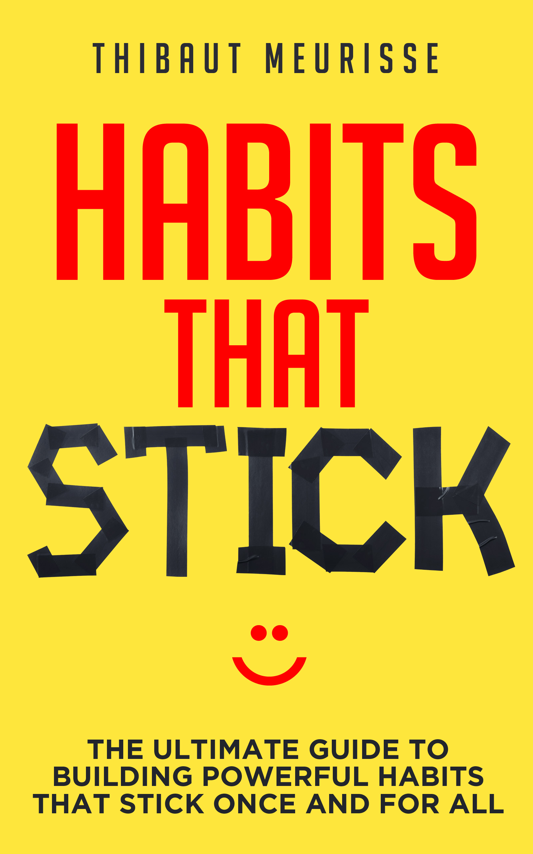

**HABITS THAT STICK**

**STEP-BY-STEP WORKBOOK**

Thanks again for purchasing my book. I really want you to succeed and to get as much as you can from it. Please make sure you use this workbook alongside the book. In the end, your commitment is what will determine how much you get out of this book.

If you’d like to further enhance your personal development journey, you can check out my goal-setting book [here](http://www.amazon.com/dp/B0149Z6EPG). Below is an example of someone who showed strong commitment and took immediate action after reading the book. That’s the key to get results in life. Good job Mark! ☺

*“For those who are curious, the book is geared towards planning to achieve any kind of goal, from simple goals, such as eating healthier, to massive dreams like changing the world. I myself have a lofty goal that I have only just begun to work on, and after reading this book I stopped everything and used the steps to lay out a plan for not only how I am going to accomplish this, but when.”* – Mark R., US

**Starting with the right mindset**

I’m convinced that trust and commitment are two of the most important factors when it comes to achieving your goals. Before we get started, please answer the following questions as honestly as possible:

1. How high is your commitment to implementing new, positive habits in your life? How much action will you take?
2. How much faith do you have that this book will help you form new habits successfully?

**Preparing Yourself Mentally**

Choose one habit* you want to implement and make a list of all the obstacles you may encounter while trying to form the new habit.

*Choose something that meets the criteria of an outstanding habit, as mentioned in the book.

**Key Point:** Be very specific. What exactly will you do? How will you measure it?

My new habit:

|  |  |
| --- | --- |
| List of obstacles | What will you do to avoid or minimize these obstacles? (IF… THEN…) |
|  |  |
|  |  |
|  |  |
|  |  |
|  |  |
|  |  |
|  |  |

Take some time to visualize what you’ll do when you encounter these obstacles.

**Making Your Habit Believable**

On a scale of **1** to **10,** how confident are you that you’ll be able to stick to your habit **every day** for the next 30 days?

If your confidence level is lower than **8 out of 10,** figure out how you can start smaller to ensure you’ll stay consistent.

Your confidence level:

**Creating the Right Environment**

Make it as easy as possible to form your new habit by creating a supportive environment.

What are you going to do to minimize the amount of willpower required for your new habit?

New Habit Example: Running every morning.

The following list illustrates ways that you can make it easier to stick to this habit:

1. Go for a run first thing in the morning (before eating, checking your phone, etc.) to avoid distractions and excuses.
2. Prepare your running gear the day before and put it near your bed so you can change and head out as soon as you wake up.
3. Before you go to bed at night, visualize yourself waking up, putting on your gym shoes, and going for your run.

**Committing to Obtaining Results**

What is your “why”? Is your habit something you think you *should* do or something you *want* to do?

How are you going to strengthen your commitment (and turn your “should” into a “want”?)

Example: Invest in a high-quality program that will motivate you to take action, hire a coach, have an accountability partner, or share your goals with people around you.

**Extra Tip :** You can also send me an email with your commitment at [thibaut.meurisse@gmail.com](mailto:thibaut.meurisse@gmail.com). I’d be more than happy to serve as your accountability partner.

I will strengthen my commitment by:

-

-

-

-

**Creating Tiny Habits**

When forming a new habit, consistency is more important than intensity. Once you’re able to successfully implement a new habit for a month or more, you can start increasing the intensity.

How can you implement your new habit in such a way that you feel confident you can stick to it for an extensive period of time?

**Extra Tip:** Ideally, your new habit should be something that’s important to you. It should be something you want to keep for months, years, or even for the rest of your life. So be ready to start small.

Examples of Tiny Habits:

* + Running habit: put your shoes on and just go out
  + Push up: do 1 push-up
  + Writing habit: open your word application and start writing
  + Diet: eat one apple a day. An apple a day keeps the doctor away (What if it is true)

Just start and say to yourself that it’s okay if you just do a little bit, as long as you do it EVERY DAY!

My tiny habit is………………………………………………………………………

**Setting Up Triggers**

What will be the trigger for your new habit? Make sure that your trigger is something that happens daily.

Some possible triggers include:

* Waking up.
* Finishing breakfast, lunch, or dinner.
* Finishing your shower.

**Example:** I will do *insert habit here* as soon as I do *insert daily activity here*.

I will………………………………………..as soon as I………………………………..

**Preparing a Plan B**

What will you do when you something unexpected happens in your life? Will you skip you habit for a few days? That’s sure to destroy it, so you have to come up with a way to work around situations like this.

Write down your Plan B below.

**Focusing on the Right Action**

Forget about the results you want to get for a while and figure out what you need to be doing. What precisely is the right action you need to take every day?

My right action:

**Taking Action**

I really want to congratulate you for going through the entire workbook. Most people won’t make it that far, but you did! You showed strong commitment. Now it’s time for you to take massive action.

The 30-Day Challenge was designed specifically to help you do just that. Your challenge is this: **Stick to your new habit every single day for the next 30 days.** How small you start is totally up to you. I already circled the first day for you ☺

Action!

**Extra Tip**: Feel free to print out the full page version of the calendar available at the end of this workbook.

|  |  |  |  |  |  |  |
| --- | --- | --- | --- | --- | --- | --- |
| 1. ○ | 2 | 3 | 4 | 5 | 6 | 7 |
| 8 | 9 | 10 | 11 | 12 | 13 | 14 |
| 15 | 16 | 17 | 18 | 19 | 20 | 21 |
| 22 | 23 | 24 | 25 | 26 | 27 | 28 |
| 29 | 30 |  |  |  |  |  |

**List of the Most Powerful Daily Habits You Can Have**

**#1** Setting daily goals.

**#2** Reading your goals every day.

**#3** Meditating.

**#4** Practicing gratitude.

**#5** Consuming motivational books, videos, or movies.

**#6** Self-reflecting

**#7** Exercising daily.

I hope you enjoyed this book and that creating new habits will be the beginning of a more meaningful and exciting life for you.

You reached the end of this workbook so you must have liked my book on habits! As a self-published author it is really difficult to market my book the way that big publishing houses can. **So, I would really appreciate it if you could take just a few minutes to leave me a review on Amazon**.

Finally, let me wish you all the best. I’m really looking forward to hearing from you on my website.

If you want keep working on yourself and make improvements in your life (which I hope you do) you can also check my goal-setting book [here.](http://www.amazon.com/dp/B0149Z6EPG)

**For your reference here is what some of the readers have to say about it:**

**[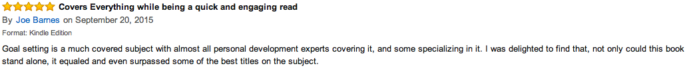](http://www.amazon.com/dp/B0149Z6EPG)**

*[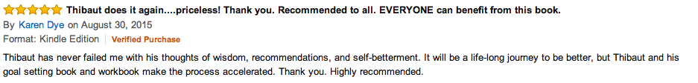](http://www.amazon.com/dp/B0149Z6EPG)*

*[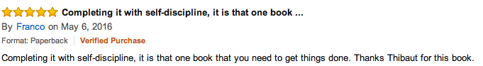](http://www.amazon.com/dp/B0149Z6EPG)*

**Click on the cover below to learn more about the eBook.**

**[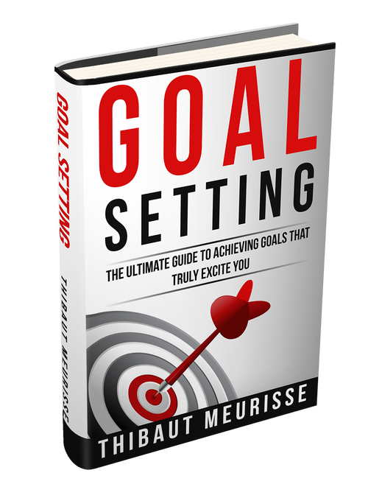](http://www.amazon.com/dp/B0149Z6EPG)**

Thanks a lot,

Thibaut Meurisse

Founder of [Whatispersonadevelopment.org](http://whatispersonaldevelopment.org/)

[](https://www.facebook.com/whatispersonaldevelopment.org/)

Reclaim your potential, reclaim your life.

Join me on Facebook [here](https://www.facebook.com/whatispersonaldevelopment.org/).

