**YOUR GOAL SETTING WORKBOOK**

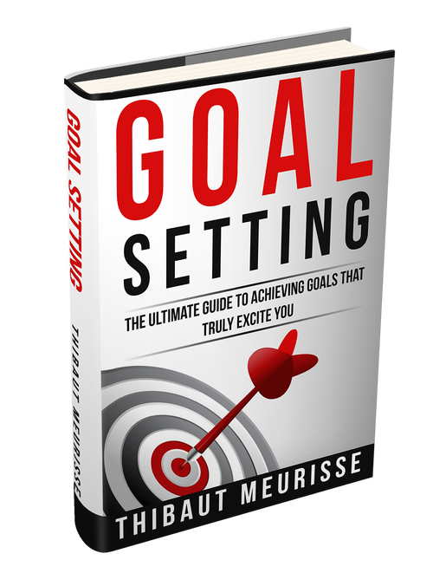

WORKBOOK

Thank you for downloading this workbook. You are now about to start setting goals for yourself. How exciting! **Please, make sure you read my e-book up to the goal setting exercise section before going through that workbook. And don’t hesitate to print it out if necessary.**

Let’s get started now!

**I. Goal Setting Exercise**

1. **If I were guaranteed to succeed what would I like to achieve?**

What do **I** really want deep down?

Write all the goals you really want to achieve no matter how crazy they might sound. Don’t worry you don’t need to share them with anybody. Make sure you cover all the areas in your life (relationship, health, career, finance…). Write as many goals as you can.

-

-

-

-

-

-

-

-

-

-

-

-

-

-

-

-

1. **How am I going to achieve these goals?**

What would the best version of yourself do to achieve these goals?

Choose your most important goal and come up with as many ideas as possible to achieve that goal.

**3. What is one tiny step that if taken today would get me closer to my goal?**

-

1. **What would achieving my goal get me?**

Identify the values behind your goal. The more you elaborate, the stronger you “why” will become, and the more realistic achieving your goal will become.

|  |  |
| --- | --- |
| Ex: What would money bring me?   * **Freedom**   + Time with my family   + Happiness   + Hobbies * **Time**   + Hobbies   + Activity to relax   + Workout/running * **Experiences**   + Travel   + Excitement   + Meet new people * **Material things**   + House   + Car * **Savings**   + Security   + Treat myself | **What would your goal get you?** |
|  |

1. **Are those values in line with my core values?**

Are there more effective ways I could meet my needs?

1. **Is my goal a worthy goal to pursue?**

* Does it reflect my core values and what I really want? Yes No
* Does it excite me? Yes No
* Am I enjoying the process of achieving that goal? Yes No
* Am I acting mainly out of love or am I trying to fill a gap within me Yes No

(feeling of not going good enough, not being worthy of love…)

1. **How clear is my goal?**

**Does your goal follow the SMART goal criteria?**

Specific, Measurable, Achievable, Relevant, Time-bound

Is your goal specific?

Is your goal measurable?

*How will you know that you achieved it?*

Is your goal achievable?

*Does your level of commitment match your goal? Is your goal realistic in the time frame set, given your daily obligations? How much time will you spent on your goal every week?*

Is your goal relevant?

*Is your goal in line with your core values?*

Do you have a clear deadline?

*Having a clear deadline make your goal more concrete, help you create a specific plan of action and create a sense of urgency*

**My specific goal is:**

|  |
| --- |
|  |

**II. STRATEGIC PLANNING**

**1. Identify the obstacles**

What are all the possible obstacles I am likely to encounter and how will I overcome those hurdles?

**2. Deal with over-optimism**

What is the worse case scenario? Multiply it by 10

Spend some time to think about it and prepare yourself mentally

**Worse case scenario:**

|  |
| --- |
|  |

**3. Create a healthy relationship with failure**

How do I perceive failure? How can I change that perception?

What am I willing to go through before giving up?

-

-

-

-

-

**4. Limiting beliefs (see**: [Second Step: Identify Your Limiting Beliefs – How To Overcome Limiting Beliefs](http://whatispersonaldevelopment.org/second-step-identify-your-limiting-beliefs-how-to-overcome-limiting-beliefs)**)**

What are my limiting beliefs? How could they prevent me from reaching my goal?

-

-

-

-

4-step method to overcome limiting beliefs:

1. Be aware of those beliefs and understand that you are not your thoughts. Welcome negative thoughts, acknowledge their existence but don’t accept them as true.
2. Ask yourself how they could manifest and try to sabotage you
3. Write a letter to your subconscious mind
4. Counterattack: “Is that limiting belief true all the time in every possible situation?” Challenge that belief every day by finding examples that shows it is not true

**5. Dealing with self-criticism**

Are you beating yourself up as a way to sabotage yourself?

Beating ourselves up is not helping you. How can you stop beating yourself up and cultivate self-compassion? Observe how you talk to yourself when you beat yourself up. Would you say the same thing to your best friend?

Write what I would say to my best friend when he had some setbacks:

**6. Planning fallacy**

Am I being over-optimistic?

How would I react if things were going way slower than I expected?

**7. Is my goal realistic?**

How do I feel about my goal? Is it inspiring me? Or am I scared of not being able to achieve it?

How I will chunk down my goal:

**III. Understanding the conditions to success**

Do I know everything I should know to reach my goal? Yes No

What step I am going to take to get the information I need:

**1. Filling the gap**

What skill(s) do I need to develop in order to achieve my goal?

**2. How much should I invest?**

* How reliable is the program I am interested in?
* How much time can I save by buying this program/How much do I value an hour of my time?
* How much money can I make or save in the long-term by using that program?
* In what extent will I avoid distraction by buying that program?
* What are other potential benefits (peace of mind, commitment to take action…)

After answering those questions, if you believe that the money/time you can save is greater than the cost of the program you should always buy it.

**3. 80/20 Rule**

What are the key tasks I should focus most of my efforts on?

-

-

-

-

**4. Deliberate practice (see** [Myth #2 – I Have Not Talent – Do You Need Talent To Be Successful?](http://whatispersonaldevelopment.org/myth-2-i-have-no-talent-do-you-need-talent-to-be-successful))

What is the best way for me to master the skills needed to reach my goal?

**5. Forming daily habits (**see [How To Form Habits Effortlessly – The Power Of The Compound Effect](http://whatispersonaldevelopment.org/form-habits-effortlessly-power-compound-effect))

What are 3 steps I can take every day to get closer to my goal?

-

-

-

What are 3 steps or more I can take this week to get closer to my goal?

-

-

-

How can I turn my tasks into daily habits?

Every day I will:

-

-

-

-

**6. Scheduling**

* Before going to bed make a list of 3 to 5 tasks that will help moving toward your goal. Now look at that list and ask yourself “If I could accomplish only one task in that list, what would it be? What one task would have the most impact?”
* Take 1 or 2 hours at the beginning of each month to plan your month
* Take 30 min to 1 hour every Sunday morning to plan your week

**2 Powerful questions to ask yourself every day**

* If I could only accomplish one task today, what is the task that would have the most impact? What about this week? This month?
* If I keep doing what I’ve done today, am I going to achieve my goal? Be honest with yourself!

**2 Powerful questions to ask yourself on a regular basis**

* How could I accomplish my goals in only 6 months? 3 months? 1 month? What about 1 week? (Assuming a yearly goal). It is a great way to brainstorm and to motivate yourself to take more action. If you are taking actions that have little impact and consciously or unconsciously procrastinate, this question will put you back on the right track. It’s a good idea to ask yourself that question every week when you plan your activities for the following week.
* Assuming I failed to reach my goal, what would be the reason for that? What can I do about it?

I hope you enjoyed this e-book and that setting goals will be the beginning of a more meaningful and exciting life for you.

You’ve got until the end of this workbook so you must really like it! You know, as a self-published author it is really difficult to market my book the way that the big publishing houses can. **So, if you could take just a few minutes to leave me a review on Amazon I would really appreciate it**. I gave a link to the book. Here is the link <http://www.amazon.com/dp/B0149Z6EPG>

Thanks!

Finally, let me wish you all the best with your goals. I’m very much looking forward to hearing from you on my website. Don’t forget to subscribe to my newsletter to get my **free e-book** “[The 5 Commandments of Personal Development](http://whatispersonaldevelopment.org/subscription)”. I will release more free e-books and other stuffs for my subscribers in the coming months. Be on the look out!

[](https://www.facebook.com/whatispersonaldevelopment.org/)[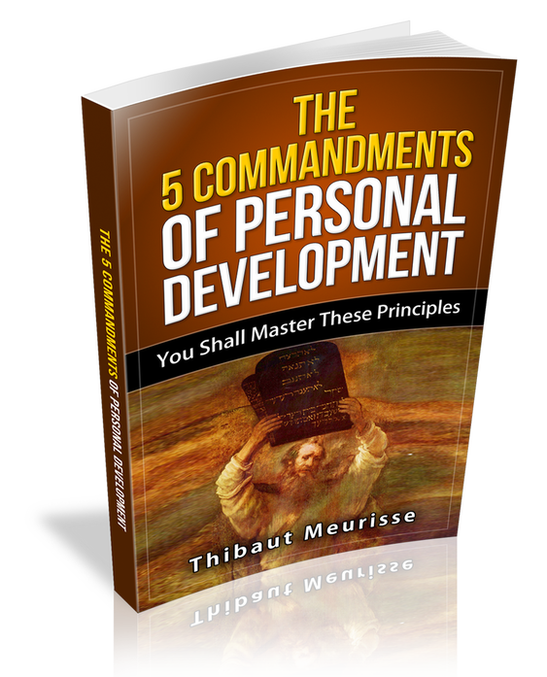](http://whatispersonaldevelopment.org/subscription)

Thanks a lot

Thibaut Meurisse

Founder of [Whatispersonadevelopment.org](http://whatispersonaldevelopment.org/)

Reclaim your potential, reclaim your life

Join me on Facebook [here](https://www.facebook.com/whatispersonaldevelopment.org/)